Student Performance Analytics System
Programming in Java – BYOP Project Report (Vityarthi)

Name- Aditi Krishnakant Soni
Reg. Number- 24BAI10490
Slot- F11+F12
Faculty- Dr. Ganesan G
Date of Submission-25th March 2026

1. Introduction
In the current academic environment, analyzing student performance plays a very important role in improving learning outcomes. Teachers and students often depend on manual methods to calculate marks and evaluate performance, which can be time-consuming and sometimes inaccurate.
This project focuses on developing a simple and efficient system using Java to manage student records and analyze their performance. The system automates tasks such as calculating averages, assigning grades, identifying weak subjects, and giving suggestions for improvement.
The aim is to make performance analysis easier, faster, and more reliable.

2. Problem Statement
In many schools and colleges, student data is handled manually or using basic tools. This creates several problems:
- Difficulty in managing multiple student records
- Time-consuming calculations
- Lack of proper performance analysis
- No clear identification of weak areas
- No automated suggestions for improvement
This project solves these issues by creating a structured and automated system using Java programming.

3. Objectives
The main objectives of this project are:
- To store student information efficiently
- To automate calculation of average marks
- To assign grades based on performance
- To identify the weakest subject for each student
- To provide suggestions for improvement
- To sort and rank students based on performance
- To build a real-world application using Java concepts

4. Methodology
The project is developed using Java and follows object-oriented programming principles.
🔹 Approach used:
- A Student class is created to represent each student
- An ArrayList is used to store multiple student objects
- A menu-driven system is implemented for user interaction
- Loops and conditional statements are used for logic
- Comparator sorting is used to rank students

5. System Design
🔹 Class Structure
class Student {
int rollNo;
String name;
int[] marks = new int[5];
double average;
String grade;
}
This class stores:
- Student details
- Marks
- Performance data

6. Implementation

6.1 Menu Driven System
- The system uses a menu to allow the user to choose operations.
- System.out.println("1. Add Student");
System.out.println("2. Display Students");
System.out.println("3. Sort by Performance");
System.out.println("4. Exit");

- 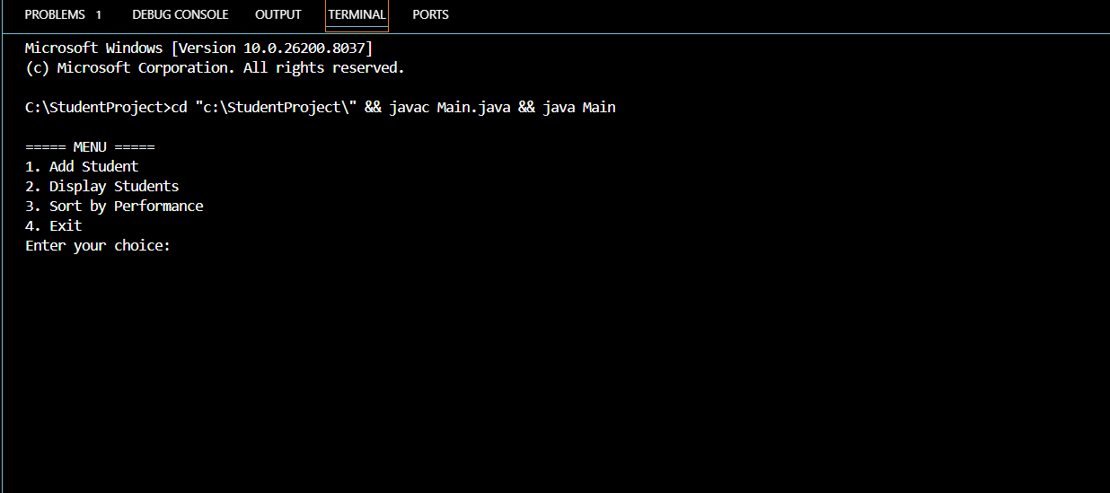

6.2 Adding Student
User enters:
- Roll number
- Name
- Marks
Student s = new Student();
s.rollNo = roll;
s.name = name;
for (int i = 0; i < 5; i++) {
s.marks[i] = sc.nextInt();
}
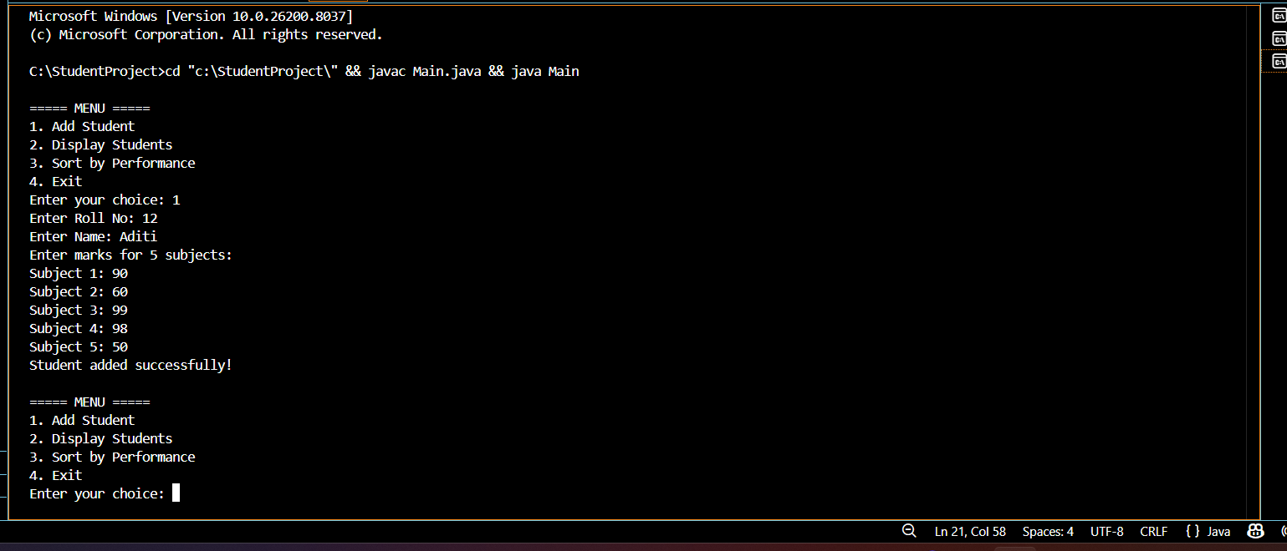
6.3 Average Calculation
int sum = 0;
for (int m : s.marks) {
sum += m;
}
s.average = sum / 5.0;

🔹
6.4 Grade Assignment
if (s.average >= 90) s.grade = "A";
else if (s.average >= 75) s.grade = "B";
else if (s.average >= 50) s.grade = "C";
else s.grade = "Fail";

6.5 Weakest Subject Detection
int min = st.marks[0];
int index = 0;
for (int i = 1; i < 5; i++) {
if (st.marks[i] < min) {
min = st.marks[i];
index = i;
}
}

6.6 Smart Suggestions
if (st.average < 50) {
System.out.println("High risk - needs serious improvement");
}
else if (st.average < 70) {
System.out.println("Needs improvement");
}
else if (st.average < 85) {
System.out.println("Good performance");
}
else {
System.out.println("Excellent performance")
6.7 Sorting Students
students.sort((a, b) -> Double.compare(b.average, a.average));
This ranks students from highest to lowest
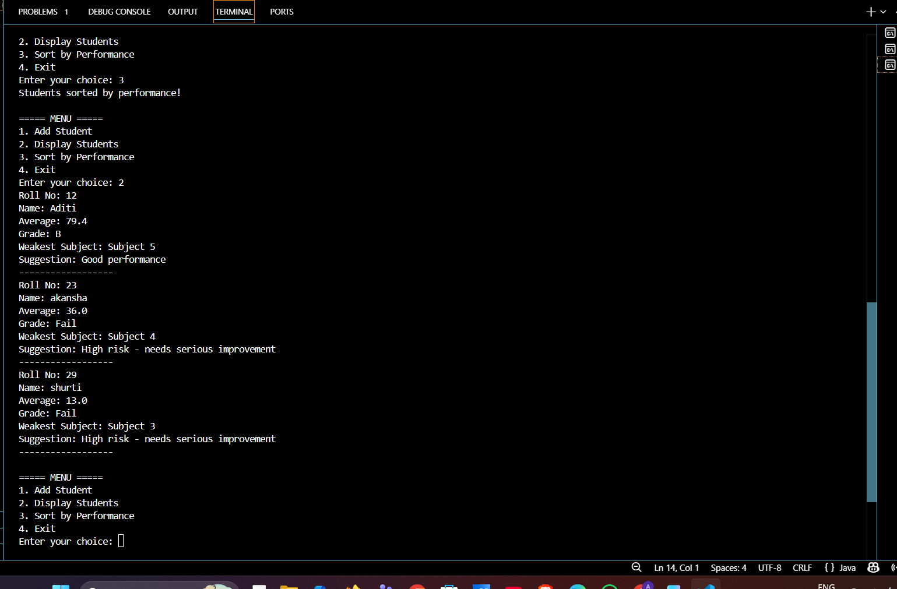
6.8 Display Function
Shows:
- Roll number
- Name
- Average
- Grade
- Weak subject
- Suggestion
- 

7. Challenges Faced
During the development of this project, several challenges were encountered:
- Handling user input correctly using Scanner
- Understanding ArrayList for storing objects
- Fixing errors like InputMismatchException
- Managing variable scope errors
- Implementing sorting using comparator
- Designing proper program flow
These challenges helped improve debugging and problem-solving skills.

8. Results
The system successfully performs:
✔ Student data storage
✔ Performance calculation
✔ Grade assignment
✔ Weak subject identification
✔ Suggestion generation
✔ Student ranking
The output is accurate and easy to understand.

9. Conclusion
This project demonstrates how Java can be used to solve real-world problems effectively. It provides a simple yet powerful system for analyzing student performance.
Through this project, I learned:
- Object-oriented programming
- Use of data structures
- Logical thinking and debugging
- Building complete applications
Overall, this project helped strengthen my programming skills.

10. Future Enhancements
The system can be improved further by:
- Adding graphical user interface (GUI)
- Using database for permanent storage
- Adding subject names instead of numbers
- Including graphical analysis (charts)
- Adding login system

11. References
- Java documentation
- Class notes
- Online tutorials

